ASSIGNMENT 3

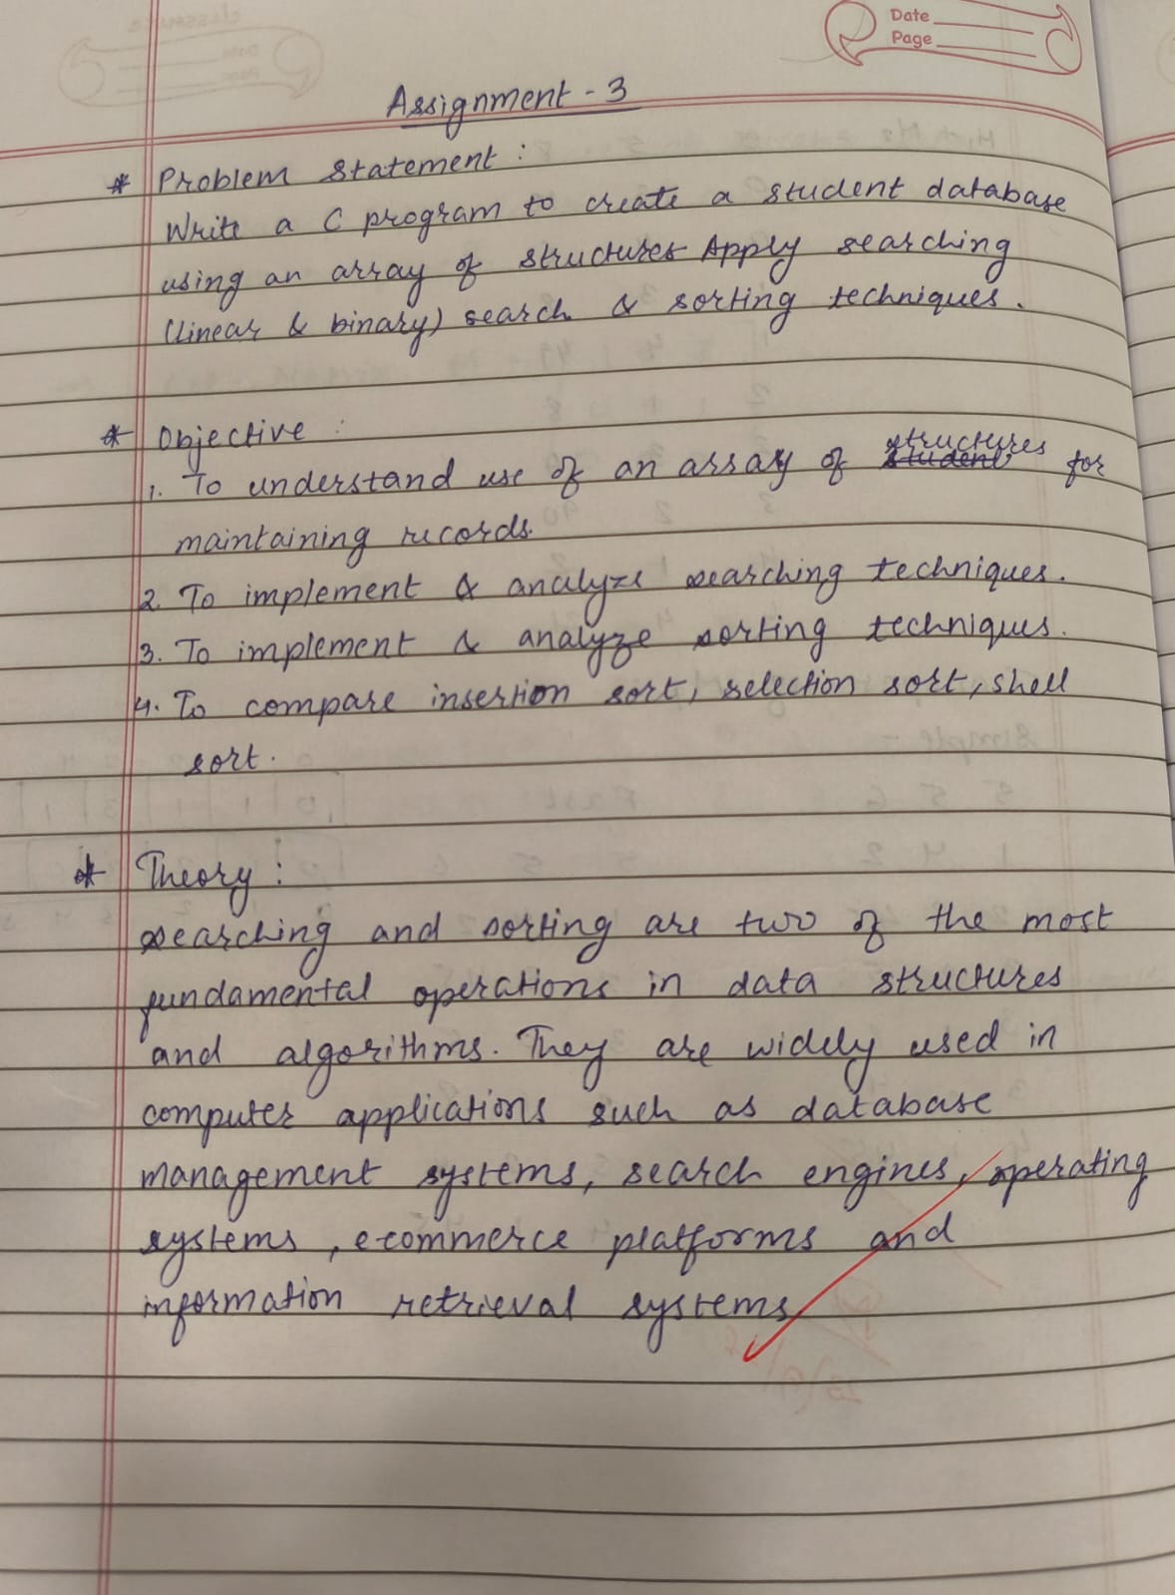
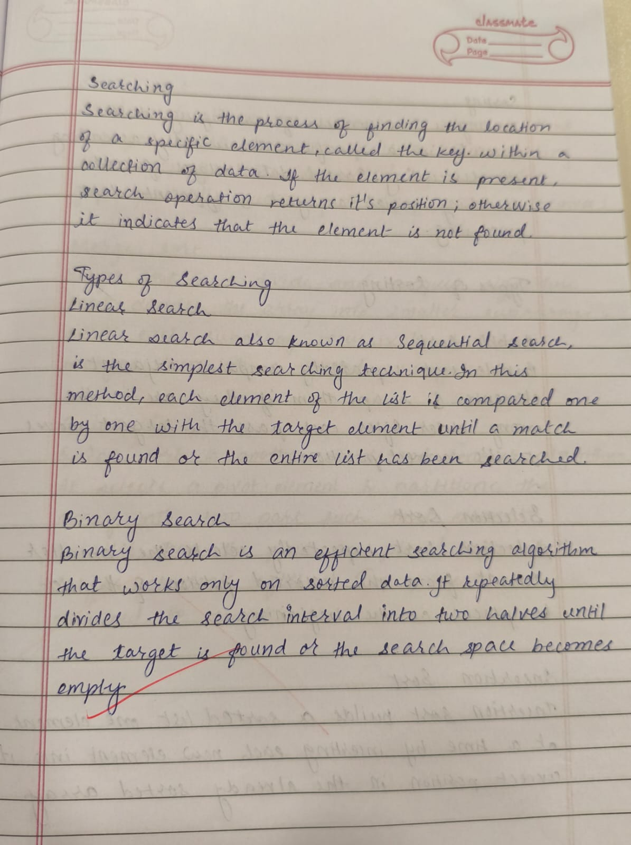
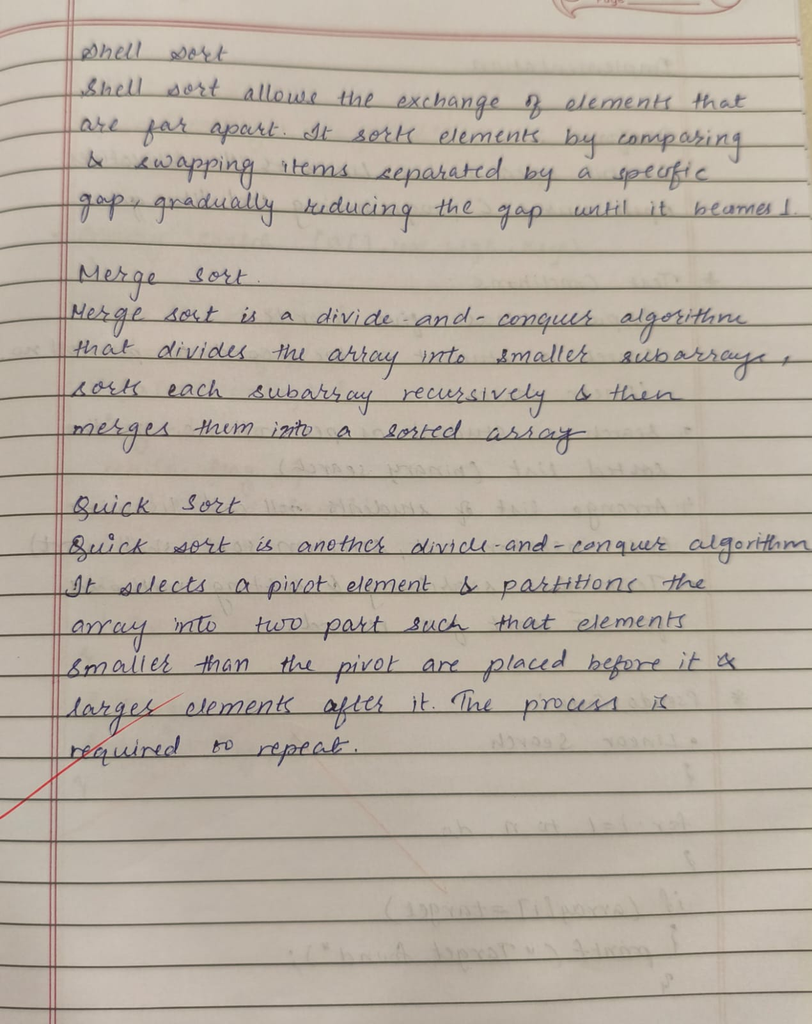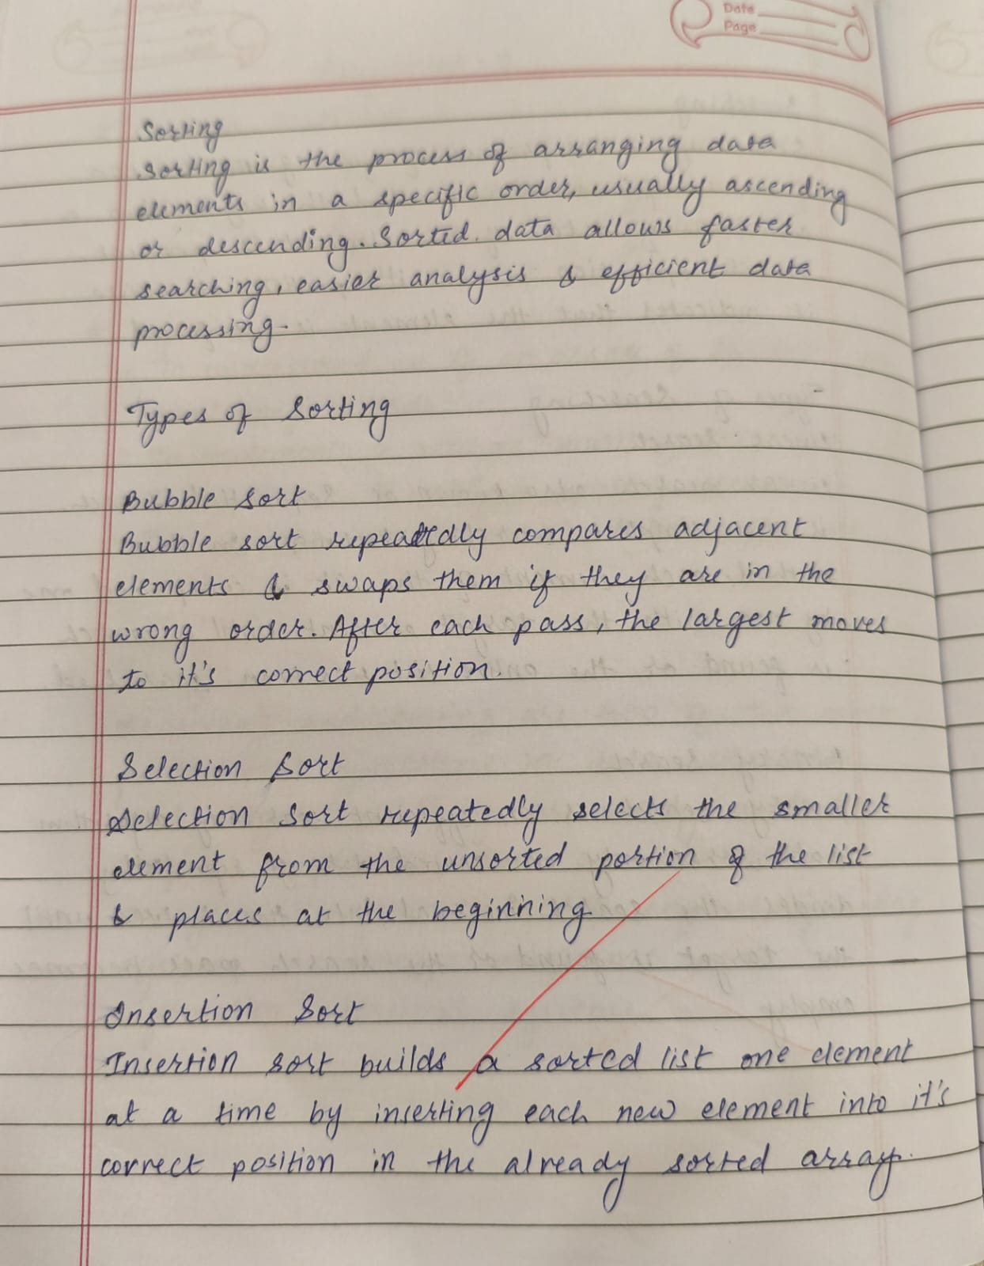
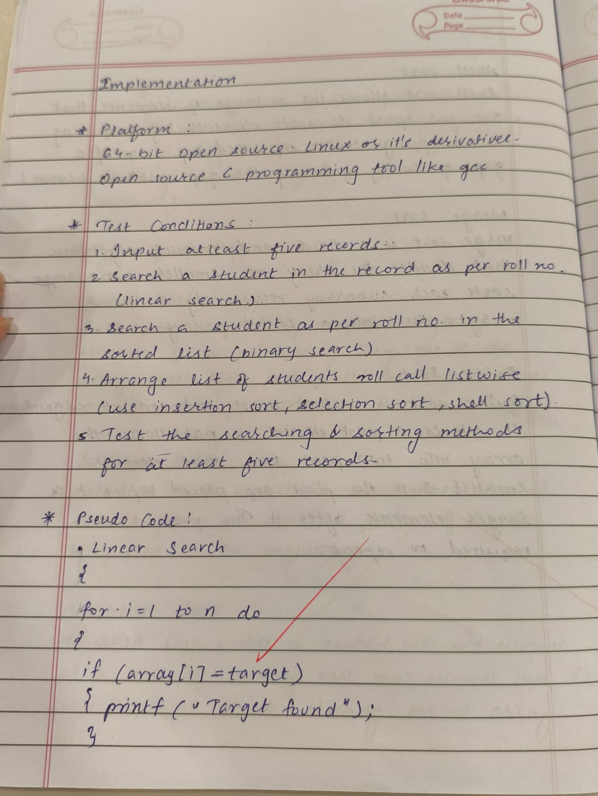
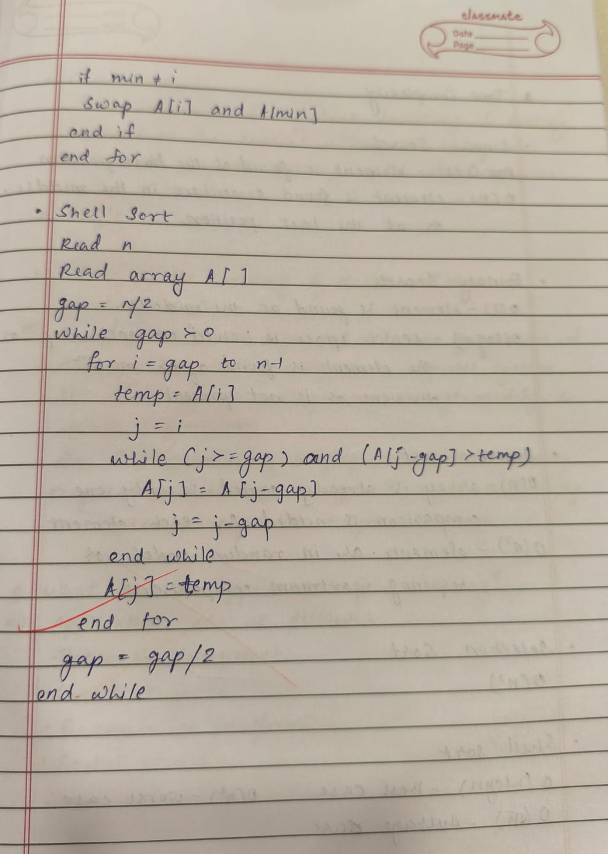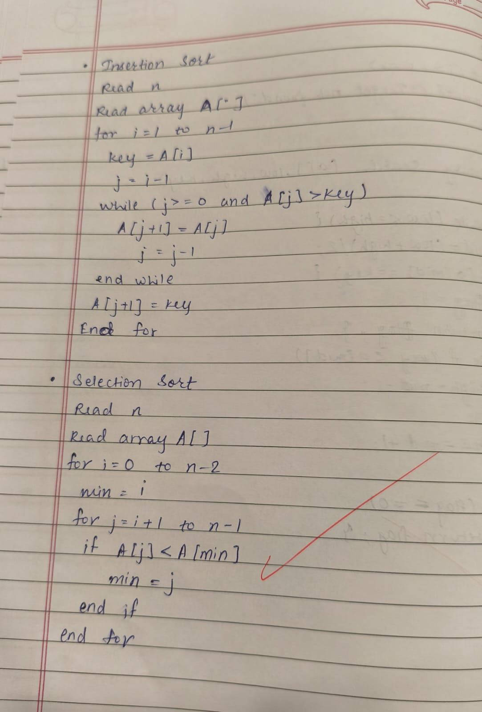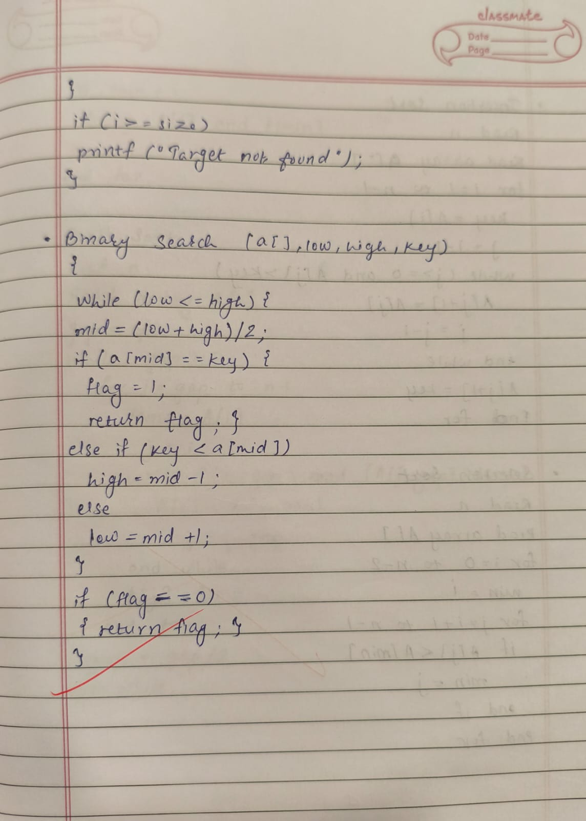
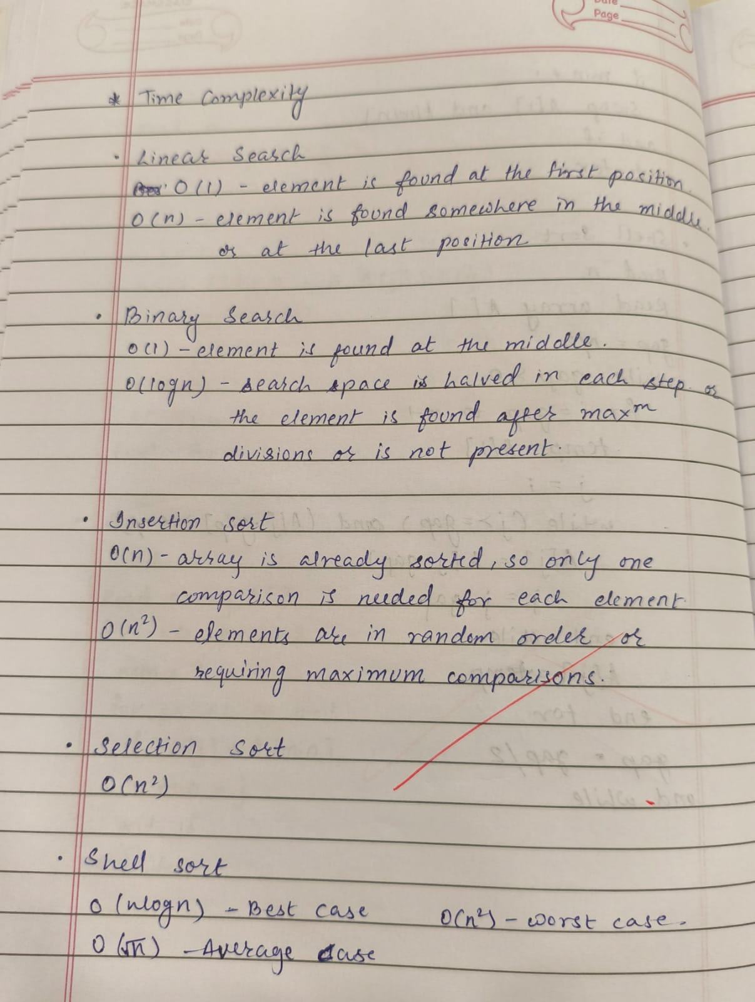
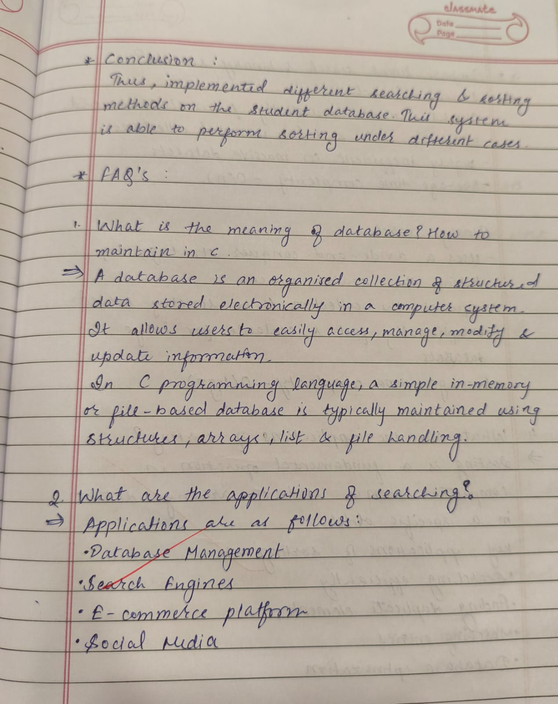
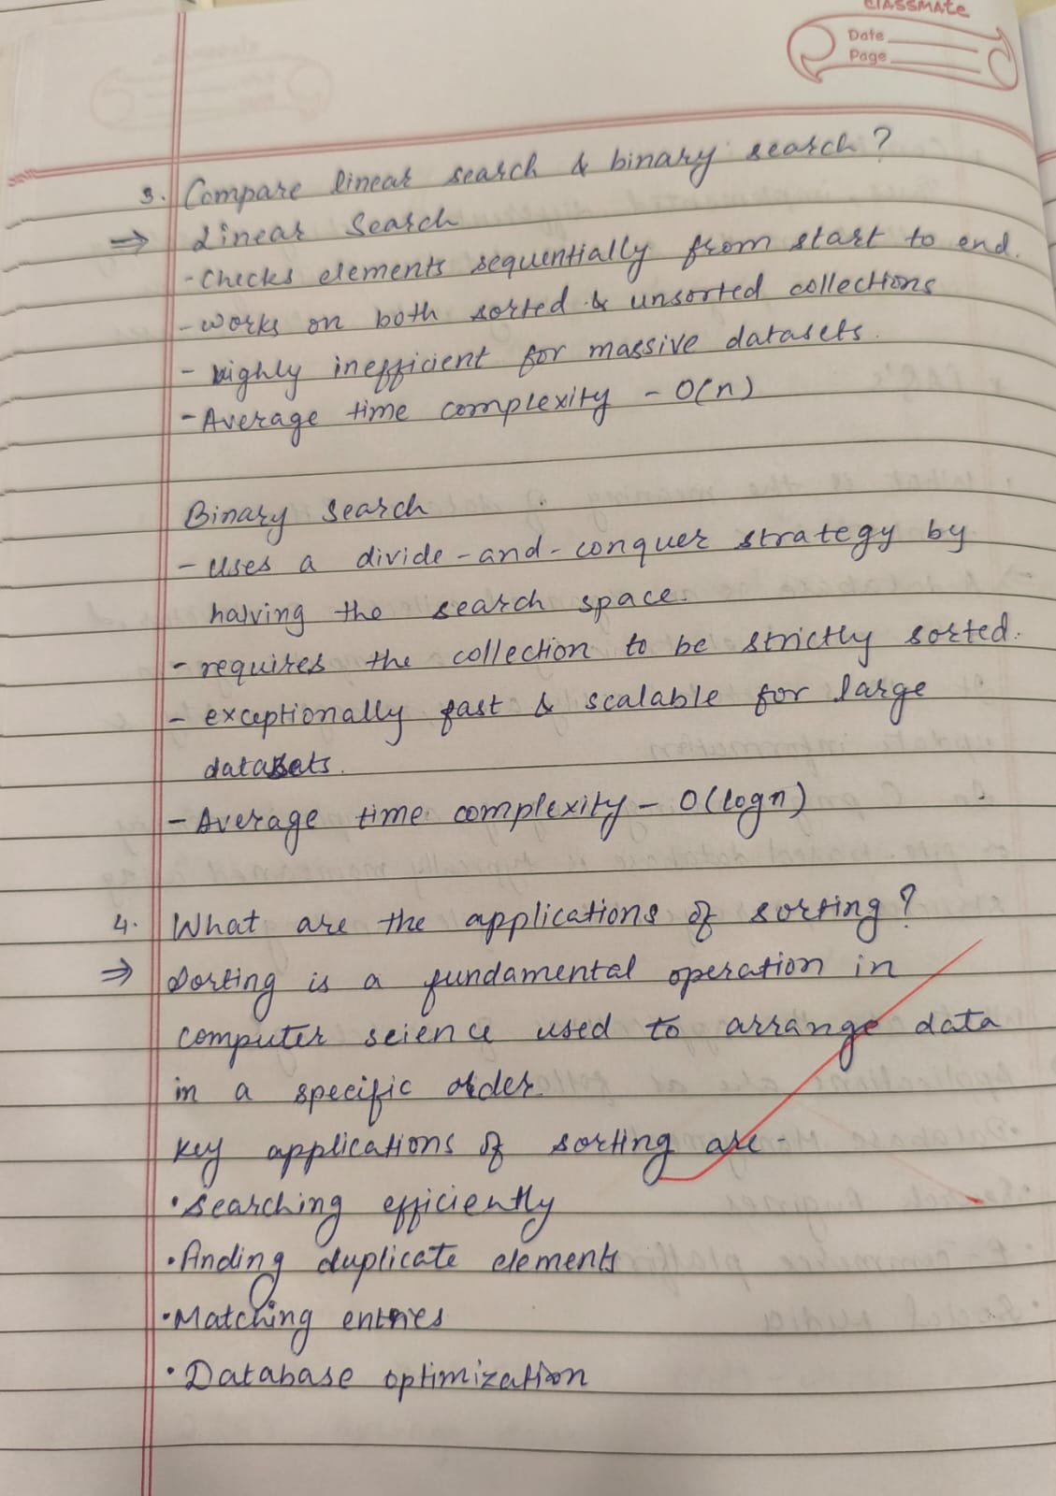
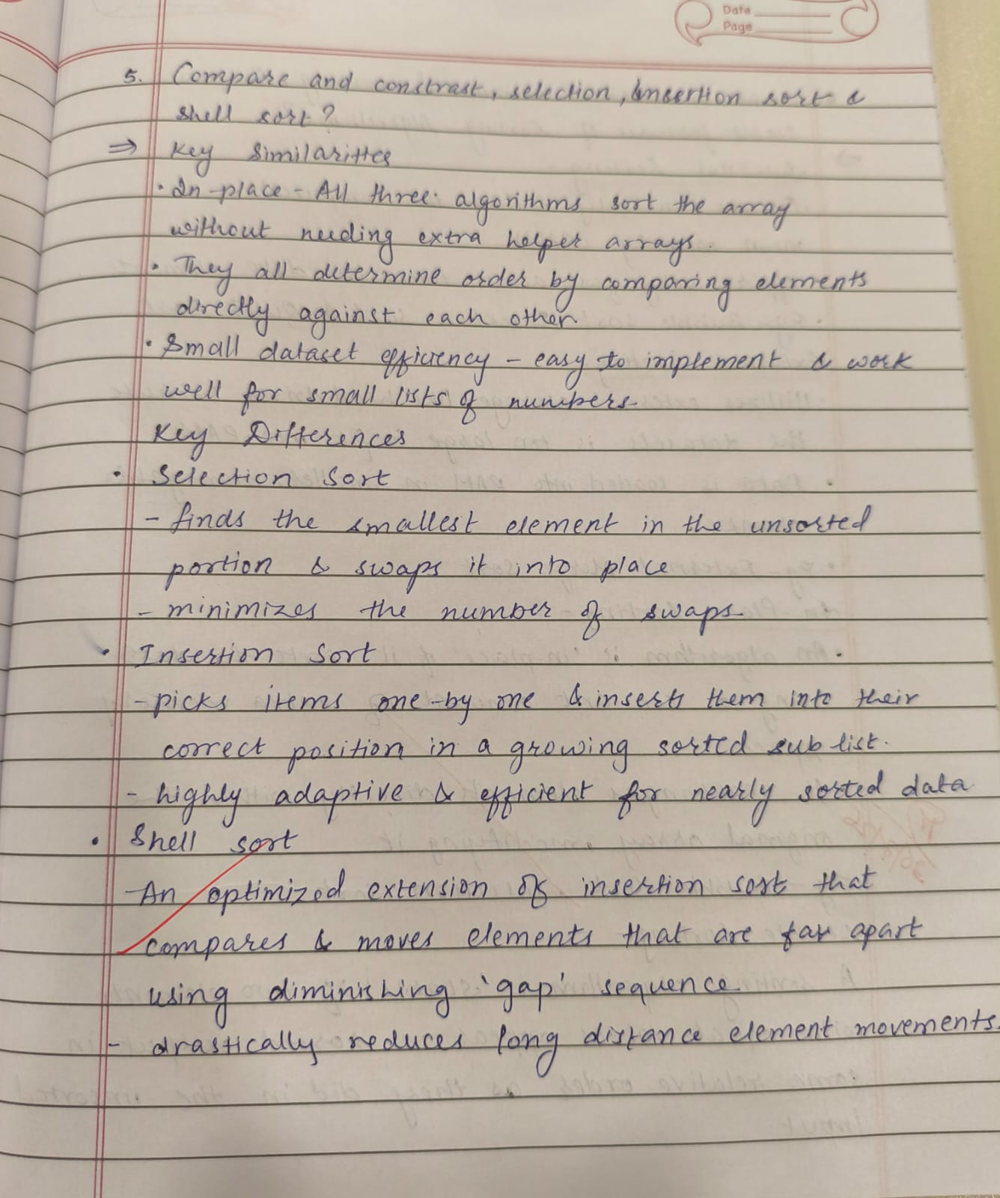

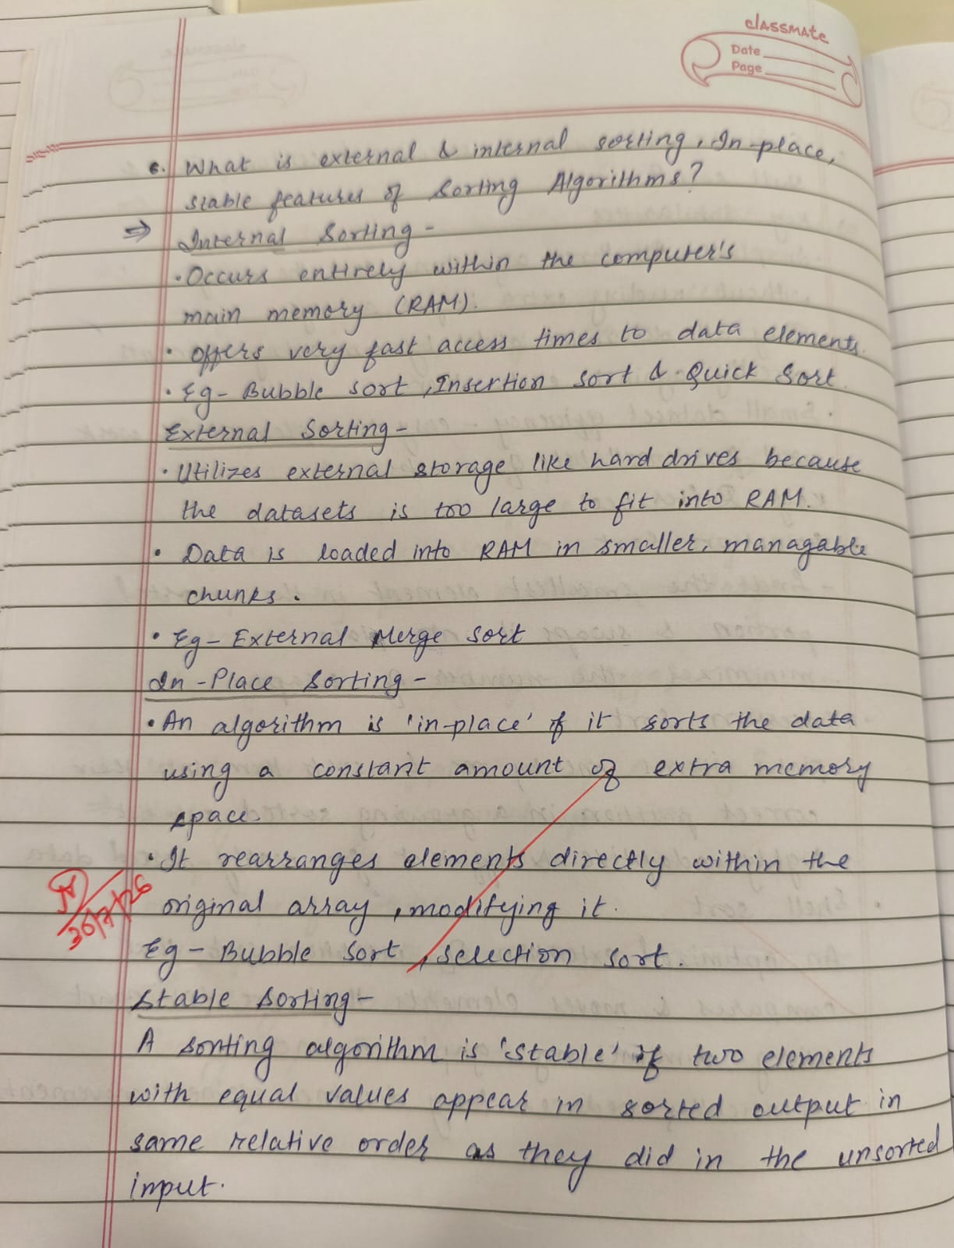

CODE :

#include <stdio.h>
#include <string.h>
#include <stdlib.h>

struct student
{
int roll;
char name[20];
float per;
int div;
}s;

void input(struct student s[20], int size)
{
int i;
for(i=0; i<size; i++)
{
printf("enter roll no, name, percentage, division:");
scanf("%d%s%f%d", &s[i].roll, s[i].name, &s[i].per, &s[i].div);
}
}

void display(struct student s[20], int size)
{
int i;
printf("Roll no\tName\tPercentage\tDivision");
printf("\n");
for(i=0; i<size; i++)
{
printf("%d\t%s\t%f\t%d\t",s[i].roll, s[i].name, s[i].per, s[i].div);
}
}

void linearsearch(struct student s[20], int size)
{
int key=0, i, found=0, c=0;
printf("\nenter roll no. to be searched:");
scanf("%d",&key);
for(i=0; i<size; i++)
{
if(s[i].roll==key)
{
found=1;
printf("\nRoll no. :%d",s[i].roll);
printf("\nName:%s",s[i].name);
printf("\nPercentage:%f",s[i].per);
printf("\nDivision:%d",s[i].div);
break;
}
c++;
}
printf("\nfrequency count: %d", c);

if(found==0)
printf("\nroll no. not found");
}

void binarysearch(struct student s[20], int size)
{
int low=0, high=size-1;
int mid, key;
printf("\nenter roll no. to be searched:");
scanf("%d",&key);

while(low<=high)
{
mid=(low+high)/2;
if (s[mid].roll==key)
{
printf("\nRoll no. :%d",s[mid].roll);
printf("\nName:%s",s[mid].name);
printf("\nPercentage:%f",s[mid].per);
printf("\nDivision:%d",s[mid].div);
return;
}
else if(s[mid].roll<mid)
high=mid-1;
else if(s[mid].roll>mid)
low=mid+1;
}

printf("\nstudent not found\n");
}

int main()
{
struct student s[20];
int size=0;
printf("Enter no. of students:");
scanf("%d",&size);

input(s, size);
display(s, size);
linearsearch(s, size);
binarysearch(s, size);
return 0;
}

OUTPUT :
